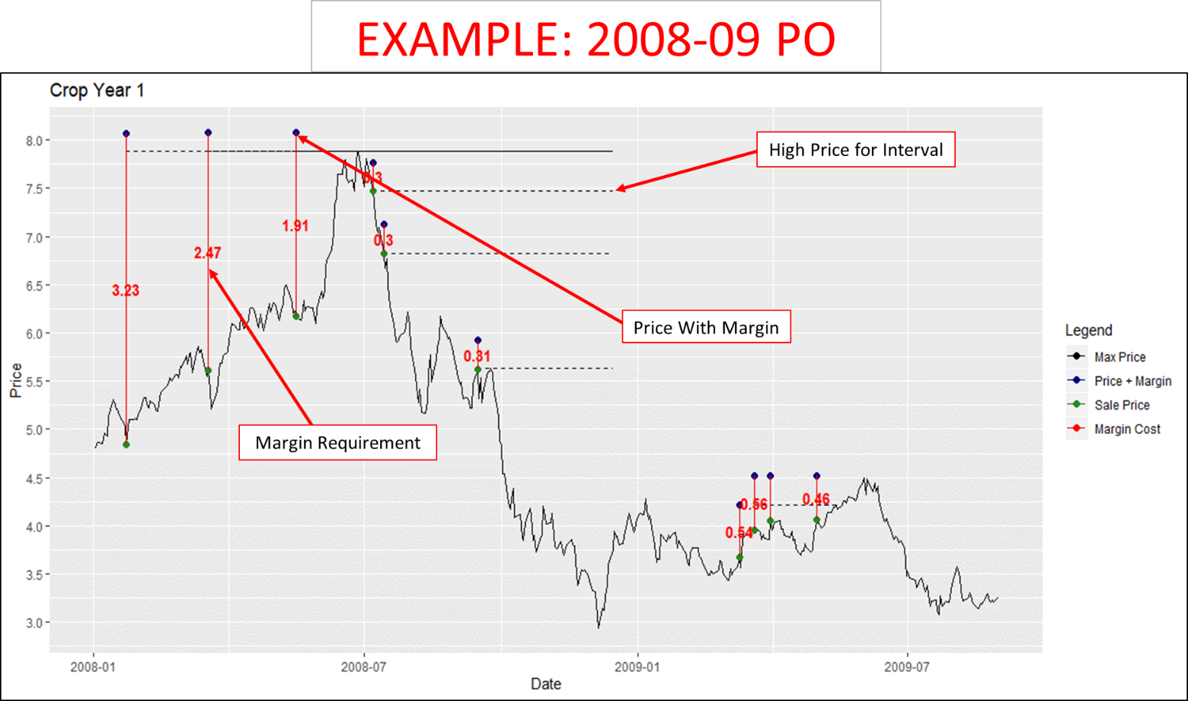

How this works:

* First sale ($4.50 +), by July maintenance margin plus margin calls total 3.23/bu for 10% of expected production
* Second sale ($5.50+), by July margins total 2.47/bu for another 10% of production
* Third sale (above $6), by July margins total 1.91/bu for another 10% of production
* After July prices decline and margin funds flow back into producer’s margin account.
  + No longer needs to have additional funds as long as enough is left in account to cover additional sales during the year.
  + Jan 1 would probably start another year of loan funding.

To finance this a producer expecting production of 100,000 bushels (600 to 700 acres) would need a marketing line of credit for at least $76,200 to finance hedge sales of 10,000 bushels each (10% of 100,000 bu:

* $2.54 average margin need for 30% of crop sales (3.23, 2.47,1.91) X 30,000 bushels =
* $76,200 Expected margin cash needs
* This is the maximum amount of margin to cover this example—lessor amounts would be needed for the additional sales and some margin would be flowing back into account as prices decline.

In the case of multi-year sales, we would need to total these maximum amounts of margin needed to arrive at an annual marketing line of credit needed based on expected production and % sold.